Abdull Haseeb
SU92-BSAIM-F24-050
BSAI-3A
LAB NO 10

📄 1) Documentation: Data Pre-Processing
Introduction
Data Pre-Processing is an important step in preparing raw data for analysis. It ensures that the dataset is clean, consistent, and ready for further processing or machine learning.
Objective
The goal of this step is to remove unnecessary or incorrect data and create a clean dataset.
Explanation
- Dataset Loading
The dataset is first loaded into a DataFrame so it can be processed easily.
- Removing Duplicate Rows
Duplicate entries can cause incorrect results.
All duplicate rows are removed to ensure data quality.
- Resetting the Index
After removing rows, the index may become inconsistent.
Resetting the index gives the dataset a clean and continuous index.
- Previewing Cleaned Data
The first few rows are displayed to verify that preprocessing was successfully completed. 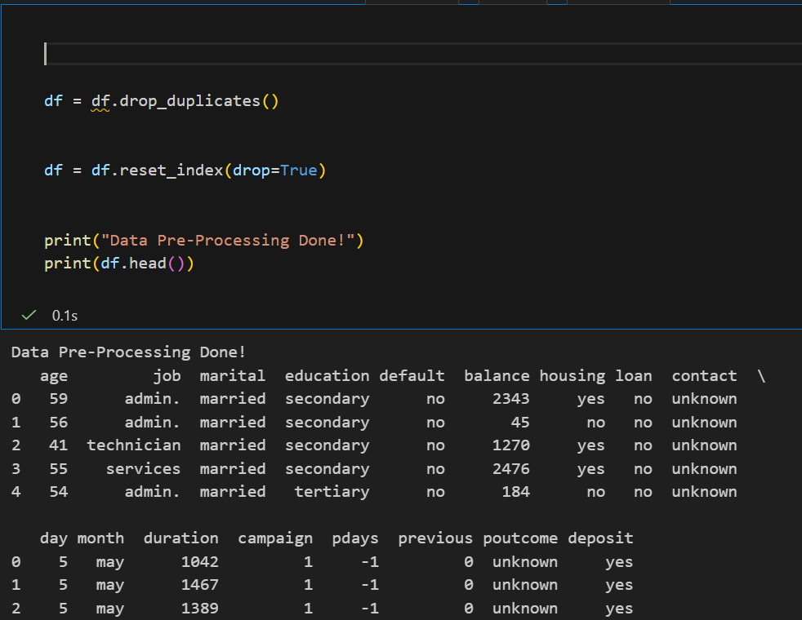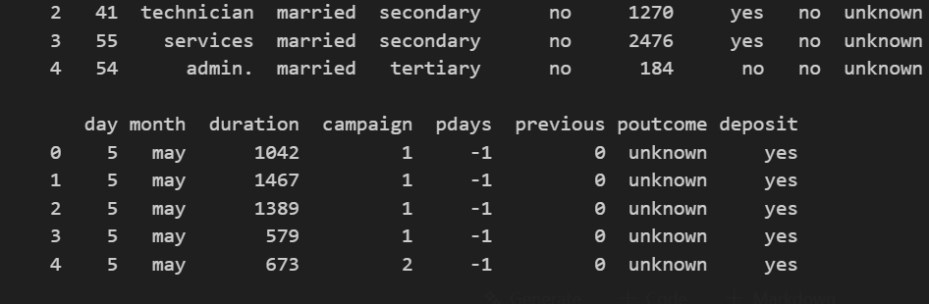
Conclusion
This step ensures that the dataset is free from duplicates and is neatly structured for further processing.

📄 2) Documentation: Dealing With Null Values
Introduction
Datasets often contain missing or null values. These missing values can affect analysis and machine learning models, so they must be handled properly.
Objective
To detect missing data and replace it using appropriate techniques.
Explanation
- Checking Null Values
Before processing, the total number of missing values in each column is checked.
- Handling Missing Values in Numeric Columns
Numeric columns are filled using the mean value.
This ensures that the numeric distribution remains consistent.
- Handling Missing Values in Categorical Columns
Categorical columns are filled using the mode (most frequent value).
This prevents issues that may occur during encoding.
- Checking Null Values Again
After processing, null values are checked again to confirm that all missing data has been handled. 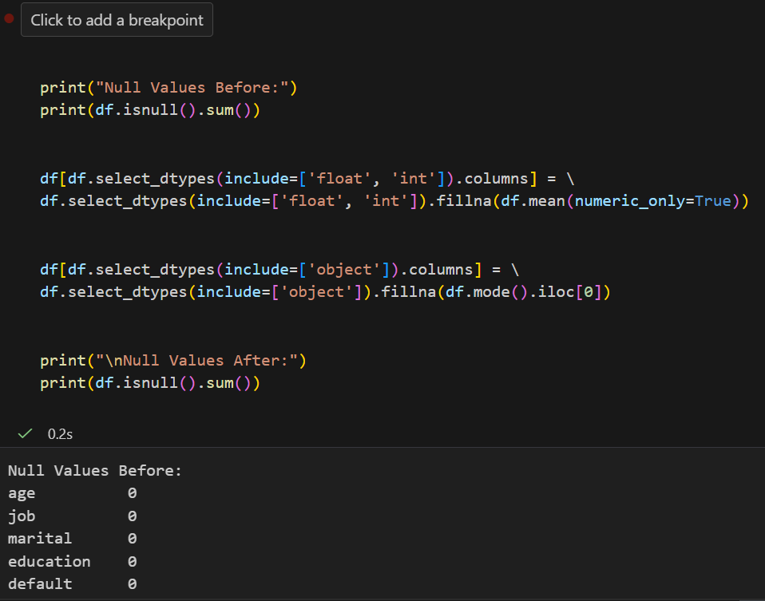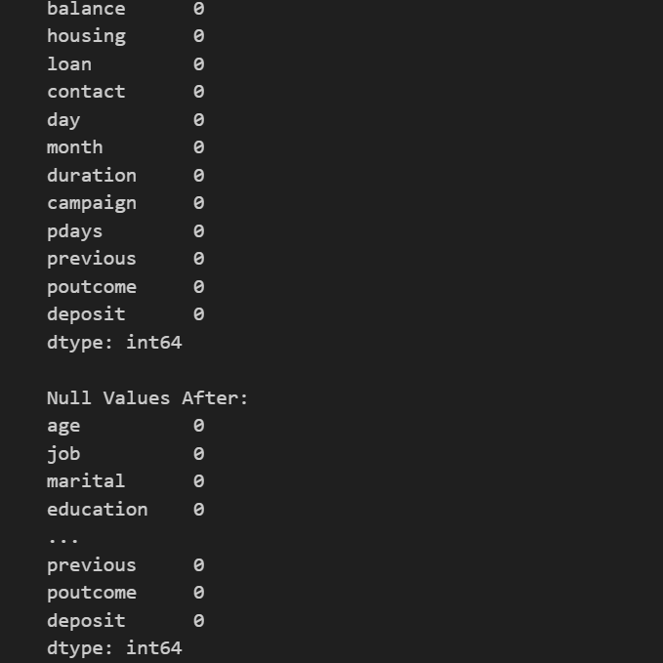
Conclusion
All missing values in the dataset are successfully filled, improving data completeness and reliability.

📄 3) Documentation: Changing Datatypes to Integer
Introduction
In some datasets, numeric values may be stored as floats or other datatypes.
For analysis, it is sometimes necessary to convert them into integers.
Objective
To convert suitable numeric columns into integer datatypes.
Explanation
- Dataset Loading
The dataset is loaded to begin the datatype conversion process.
- Checking Each Column
Each numeric column is evaluated to see if it contains only whole numbers.
- Converting to Integer
If a column contains whole numbers (no decimal part), it is safely converted to the integer datatype.
- Displaying Updated Datatypes
All updated column datatypes are displayed to verify that the conversion was successful. 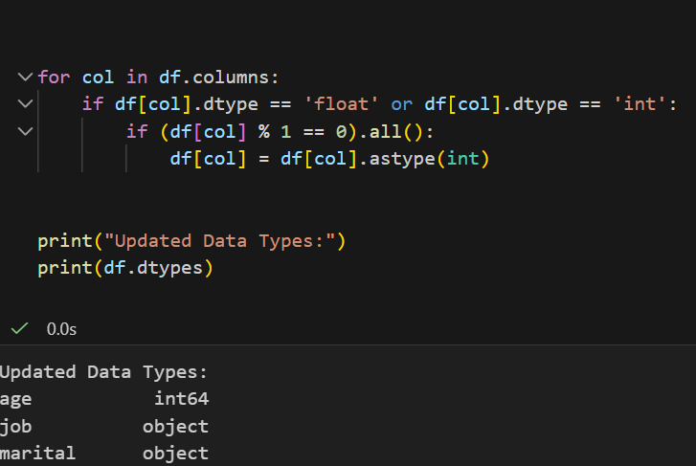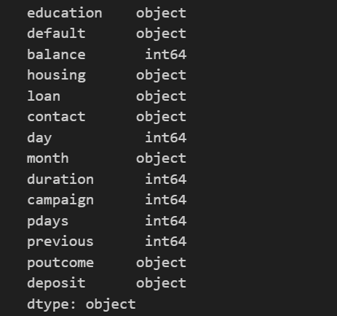
Conclusion
Only columns that are safe to convert get changed into integers, ensuring data consistency without losing any information.

